CIS 350/3501 Summer 2024 Program 3
Dynamic Minimum Spanning Trees
Due: 6/11/2024
Total Points: 100
Overview:

The problem to solve is using a priority queue to compute a minimum spanning tree.

Given a fully connected undirected graph where each edge has a weight, find the set of edges with the least total sum of weights.

You are a civil engineer and you have been tasked with trying to find out the lowest cost way to build Internet access in CIS-Land. There are X (3 ≤ X ≤ 100,000) towns in CIS-Land connected by Y (X-1 ≤ Y ≤ 100,000) roads and you can travel between any two towns in CIS-Land by travelling some sequence of roads. With a limited budget you also know that the cheapest approach to obtain Internet access is to install fiber-optic cables along existing roadways. Fortunately, you know the costs of laying fiber-optic cable down along all the roads, and you will be able to cost out how much money CIS-Land will need to spend to successfully complete the Internet access project – that is, every town will be connected along some sequence of fiber-optic cables. Good thing, you are also CIS-Land’s brightest computer science professional, and you remember learning about an algorithm, Prim’s specifically, in one of your UM-D programming classes. This algorithm turns out to be exactly what you need to solve this problem, but to implement the algorithm you will need to use a priority queue.

You would ask, why would I use a priority queue in Prim’s algorithm? The reason why people use it is because it significantly speeds up the runtime of the algorithm. It turns from O(V² + E) to O(E*log(V)).

Basically, at each step in Prim’s algorithm, you're looking for the minimum edge with one vertex in the partial minimum spanning tree, and one vertex not in the tree, and you're going to add that edge to the tree. How do you do that efficiently? If you have a way to efficiently order all the edges connected to a vertex in your partial spanning tree, you can simply iterate through them until you find an edge with an acceptable vertex.

Without such an ordered data structure, you'd have to iterate through all candidate edges each time to find the minimum, rather than being able to efficiently grab the minimum directly.

The input data describing the graph will be the nodes and associated list of edges (roads and their fiber-optic cost). The program will need to covert that input into to an adjacency list: for every node in the graph (town in CIS-Land), there will be list of the nodes (towns) it’s connected to and the weight (cost of building fiber-optic cable along).

adj[0] → (1, 1) (3, 3)
adj[1] → (0, 1) (2, 6) (3, 5) (4, 1)
. . .

First, the adjacency list could be represented as a list of vectors, one for each node.

For the priority queue, you may use any built-in library routines to implement the Priority Queue or Adaptable Priority Queue.

Input Format
Input and output file names are to be entered by the user.

Line 1: Two space-separated integers: X , the number of nodes in the graph, and Y , the number of edges.
Lines 2 . . . Y+1 :

Line i contains three space-separated numbers describing an edge:
s_{i} and t_{i} , the IDs of the two nodes involved, and w_{i} , the weight of the edge.

Sample input (input file name format is CIS-Land#.dat where this is file CIS-Land1.dat)

6 9
0 1 1
1 3 5
3 0 3
3 4 1
1 4 1
1 2 6
5 2 2
2 4 4
5 4 4
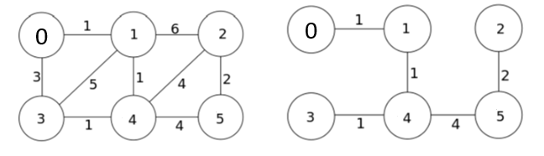
Graph MST

Line 1: 6 nodes (0 – 5) and 9 edges to follow line 2 - 10
Line 2: 0 1 1 describes edge between 0 and 1 of weight 1
Line 3: 1 3 5 describes edge between 1 and 3 of weight 5
…

The MST sum is 1+1+1+4+2 = 9

Output to Screen and File (output file name format: MST#.out)
Echo print the input (format appropriately per display messages in program)

Print the adjacency list for the full graph

Print the edge list and adjacency list for the MST – see example below

Some Assumptions
Input format is correct
Input line 1 numbers are correct if not less than 0

Example Exception Handling
File handling (file does not exist,empty) stop program
Error if node on edges do not exist error message to screen and file
- error in file – continue next input

Example output for first graph CIS-Land2.dat
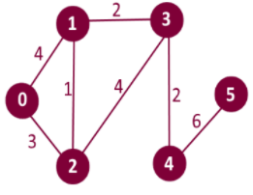

6 vertices (numbered 0 – 5) and 7 edges

6 7
0 1 4
2 3 4
1 3 2
0 2 3
4 5 6
1 2 1
3 4 2

Full Graph – Adjacency List (note: order does not matter)
Adj[0] -> (1,4) (2,3)
Adj[1] -> (0,4) (2,1) (3,2)
Adj[2] -> (0,3) (1,1) (3,4)
Adj[3] -> (1,2) (2,4) (4,2)
Adj[4] -> (3,2) (5,6)
Adj[5] -> (4,6)

MST
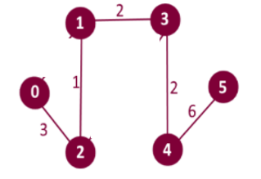
Minimum Spanning Tree
Edge: 1 - 2 weight: 1 resultSet[1] parent 2 weight 1 1 – 2 weight 1
Edge: 2 - 0 weight: 3 resultSet[2] parent 0 weight 3 2 – 0 weight 3
Edge: 3 - 1 weight: 2
Edge: 4 - 3 weight: 2 for (int i = 1; I < numberOfVertices; i++)
Edge: 5 - 4 weight: 6 {cout << “Edge: “ << I << “ – “ << resultSet[i].parent
Total cost of MST: 14 << “ weight: “ << resultSet[i].weight << endl;}

MST Graph – Adjacency List
Adj[0] -> (2,3)
Adj[1] -> (2,1) (3,2)
Adj[2] -> (0,3) (1,1)
Adj[3] -> (1,2) (4,2)
Adj[4] -> (3,2) (5,6)
Adj[5] -> (4,6)

REQUIRED FILES/TESTS:

Input file does not exist or is empty – error message to screen and output file - stop program

You MUST submit three additional test files to the 4 files below WITH entries in the test plan for tests you created
CIS-LAND1.dat
6 9
0 1 1
1 3 5
3 0 3
3 4 1
1 4 1
1 2 6
5 2 2
2 4 4
5 4 4

CIS-LAND2.dat
6 7
0 1 4
2 3 4
1 3 2
0 2 3
4 5 6
1 2 1
3 4 2

CIS-LAND3.dat (listed error edges)
6 16
0 1 1
1 3 5
-3 1 4 invalid source vertex
3 0 3
3 4 1
6 1 6 invalid source vertex
1 4 1
1-3 4 invalid destination vertex
2 4 0 invalid weight
1 2 6
5 2 2
2 4 -3 invalid weight
2 4 4
5 14 5 invalid destination vertex
5 4 4
15 3 7 invalid source vertex

CIS-LAND4.dat
5 3 invalid the number of edges
0 3 5
0 4 6
1 2 4
Turn-in Template
- test plan version 2 will have additional test cases you need to add
- algorithms are logic as close as possible without coding and testing so do expect to have to change some aspects (hence update algorithm) as you code and test

Implementation tips:
- How to create a priority-queue of pqData in C++
#include <queue>
.....
struct pqData
{
int keyWeight, keyDestinationVertex, keySourceVertex;
};
......
//declare a class Compare and overload operator()
class Compare
{
public:
bool operator() (const pqData & lhs, const pqData & rhs) const
{
return (lhs.keyWeight > rhs.keyWeight); //min priority
}
};
......
//create a priority-queue of pqData
priority_queue<pqData, vector<pqData>, Compare> pq;

What to turn in:
Upload all your files as a single ZIP file to the Canvas under the Assignment “P3” folder. You should include the following documents in your submission:
- The turn-in report (a single word or pdf file)
- All your source codes
- All your input and output files

